How are they faring?

South Australia's 2021 Report Card for children and young people

South Australia’s annual Report Card reveals how our youngest citizens are faring in:

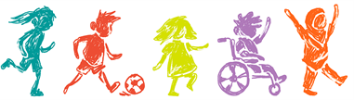
Health
Safety
Wellbeing
Education
Citizenship

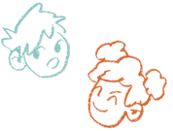  Children and young people make up 21% of South Australia's population | 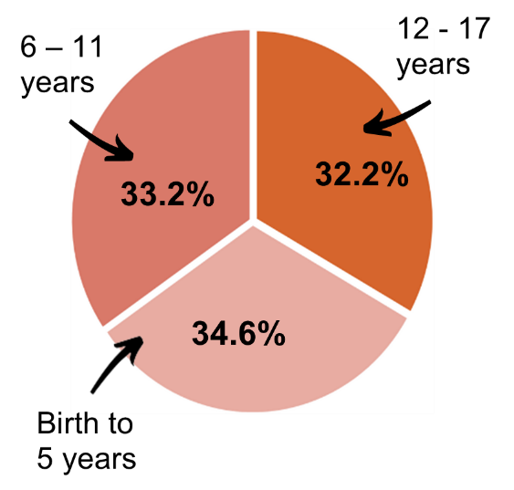 | There were 369,400 children and young people under 18 years estimated to be living in South Australia in 2021
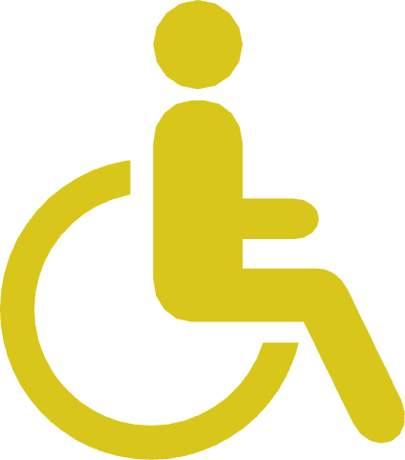  16.7% live with disability | 1.12% live in out-of-home care | 4.9% are Aboriginal

Key priorities

To improve outcomes for South Australian children and young people, all oversight and advocacy bodies and state and local government agencies continue to work together on these six priority areas:

Children entering the education system with unidentified disabilities and developmental delays
Increasing obesity rates of children and young people, particularly of adolescent girls
Poorer outcomes for Aboriginal children and young people
Mental health concerns for children and young people (especially those from disadvantaged areas)
Dual status’ children and young people who are involved in both the child protection and the youth justice systems
Monitoring the impacts of the Covid-19 pandemic

Priority for action 2022

Addressing data gaps and data quality for improved decision making

Outcomes at a glance

In summary, most of South Australia’s children and young people are faring well and ...

- are in good health
- are in safe circumstances
- have a positive sense of wellbeing
- are undertaking education
- are developing skills for civic life

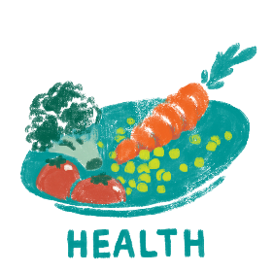  Most …  - babies are born healthy children enjoy a healthy early life  - young people appear to be thriving physically  97% of Aboriginal 5-year-olds and 95% of all 5-year-olds were fully immunised in 2020  10% of young people reported ever having smoked tobacco in 2017  80% of children and young people consider themselves to be in good or excellent health in 2021 | 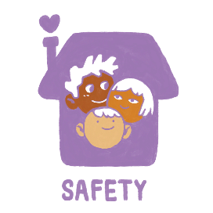  Most …  - live in safe housing  - are safe from preventable injury, abuse and neglect, and crime  79% of children and young people live in households without financial stress  99% of children and young people have housing | 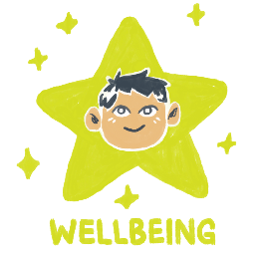  Most …  - feel connected to family, friends and culture and are optimistic about life  - participate in cultural or organised activities, such as sport  Year 4 to Year 10 students...  88% participate in organised activities outside of school  82% feel optimistic about life  78% participate in organised sport or recreational physical activities | 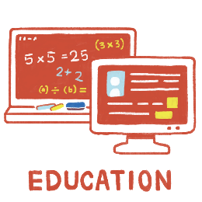  Most …  - report having positive learning experiences  - are fully engaged in school, further education, training or work  - are achieving minimum standards in reading, writing and numeracy  88% of young people (15-19  years) are fully engaged in school, work, or further education and training in 2021  67% of government Year 1 students met the expected achievement in their 2021 Year 1 phonic screening check  90% of young people completed a senior secondary certificate of education qualification or equivalent in 2019 | 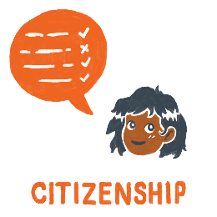  Most …  - are developing skills for living an independent life  - want to be active citizens, participate in their communities and have their ideas and views considered  89% of Year 9 students met or exceed minimum standard in reading (2021)  66% of 19-year-olds have their driver’s licence (2018)

Areas of concern include:
8% obesity | 4,100 were in out-of-home care in 2020, up from 3,800 (2019) | 11% of children and young people do not have at least one close friend | 24% of children starting school were developmentally vulnerable (2018)
13% of babies born to Aboriginal mothers were of low birthweight (2019) | 37% of all children and young people in out-of-home care at 30 June 2020 were Aboriginal | 2/5 children and young people did not feel connected to an adult at school | 80% Aboriginal school attendance rate in 2019 (on average, students miss one day of school per week)
 | 2,200 children and young people were the subjects of substantiations of notifications in 2019-20

Some experience poorer outcomes because of...
economic and social inequalities; intergenerational disadvantage; social, built environment and transport barriers; being in out-of-home care and/or detention.

